 | Hkkjrh; izksS|ksfxdh laLFkku xqokgkVh  Indian Institute of Technology Guwahati  Guwahati 781 039, India

Faculty-in-Charge, Techniche

 | Name | Period
 | Name | From |  |  | To
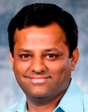 | Dr. Ajit Mazumdar, ME | 19/4/2005 |  |  | 18/4/2006
Chairman, Technical Board

 | Name |  | Period
 |  |  | From |  | To
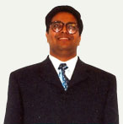 | Dr. R. Uppaluri,  CL |  | 18/1/2006 | 17/1/2008
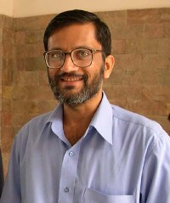 | Dr. H. B. Nemade,  ECE |  | 19/8/2008 | 15/02/2012
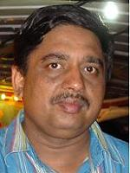 | Prof. Manmohan Pandey,  ME |  | 16/02/2012 | 15/02/2014
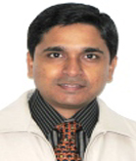 | Dr. Hemant B. Kaushik,  CE |  | 16/02/2014 | 15/02/2016

